**Subject: Multimedia**

**Final Work**

**Viktoria Panzio Fan Club**

|  |  |  |
| --- | --- | --- |
|  | | |
|  |  |  |

Document Version 1.1

2022.12.13.

DQ4WX0 Takahiro FUJIWARA

University of Dunaújváros

**Change History** (This page is not printed, by the font attribute)

|  |  |  |  |
| --- | --- | --- | --- |
| Date | Version | Modification | Contributor |
| 2022.12.03 | 1.0 | Initial version | Takahiro |
| 2022.12.13 | 1.1 | Copyright acceptance | Takahiro |
|  |  |  |  |
|  |  |  |  |
|  |  |  |  |
|  |  |  |  |

**Contents**

1. Introduction 3

1.1. What is Viktoria Panzio Fan Club? 3

1.2. Copyright of each Picture Content 3

2. Running and Development Environment 3

2.1. Running Environment 3

2.2. Deployment Format 3

2.3. Development Environment 3

2.4. Development Software 3

3. User Interface 4

3.2. Section and Tab in the Publishing content 4

3.3. General Navigation 5

3.4. Automatic Play 5

4. Special Contents “My Work” 6

4.1. Stykz 6

4.2. Animation 6

5. Some ingenuity in the work 7

5.1. Video File Format in NeoBook 7

5.2. Embedded File 7

5.3. Pixel size for the picture and movie 7

## Introduction

This document explains the User Interface of the content “Viktoria Panzio Fan Club”. Developing work is explained as well.

### What is Viktoria Panzio Fan Club?

There is actual hotel “Viktoria Panzio” in Dunaújváros ( <https://panzioviktoria.hu/> ) where, I am living there since September 2020. At first, I just think to make an introduction contents, however I need to insert Quiz page also I wanted to insert my work of animation GIF and Animation movie which I created in this subject Multimedia.

So, just changed the name to “Viktoria Panzio Fan Club”. Actually, there is no fan club, it is just a virtual club.

### Copyright of each Picture Content

Picture contents are taken from the web site <https://panzioviktoria.hu/>, or photo taken by Takahiro FUJIWARA. I got acceptance from a hotel owner about using all pictures and names.  
 Map information is taken from Google Maps. This is an educational content so the acceptance of using map is not checked.

## Running and Development Environment

### Running Environment

Windows 10 and Windows11. Both are tested.  
Screen size: Greater or Equal to 800x600 pixels.

### Deployment Format

Windows EXE file (32bit application)  
All materials such like video file and picture files are embedded in the EXE file, using NeoBook Embedded function. All materials are tested with non-developed PC (Windows11).

### Development Environment

Windows 10 22H2  
Memory 16GBytes

### Development Software

#### NeoBook

NeoBook 5.7.1 by NeoSoft Corp is used. Actually, NeoBook is discontinued product, but it is still able to create this kind of publication contents easily. For your information: There is a successor software which name is VisualNeo for windows / VisualNeo for WebApps & Mobile.

#### Additional Software

* Photo Editing: [Photopea | Online Photo Editor](https://www.photopea.com/)
* Video Format Converter: Any Video Converter Professional
* Screen Recorder: Screenbits

## User Interface

This content is like a kind of publishing contents – all contents are fixed at the development time. It is consisted with following structure.

#### Section and Tab

There are following sections:

|  |  |
| --- | --- |
| Section | Description |
| Top Page | Top page of this publishing content. |
| Public Space | Showing the public space of the hotel. |
| Rooms | Showing the rooms of the hotel. There is sub structure – following tab pages.   * Superior * Single Apartment * Double Apartment * Family Room   Each tab page has several pictures, and it is showing such like pages for each picture. |
| Site and Map | Showing the area map and landmarks. |
| My Work | This is not a hotel content. Trial of showing animation gif and animation file, which are created in my room of this hotel. There are 2 pages.   * Animation GIF created by **Stykz** * Fairy tale movie file created by **Adobe Animate** |
| Quiz | Quiz related to this hotel. |

### Section and Tab in the Publishing content

**Tab page** for each Room type  
- Superior  
- Single  
- Double  
- Family

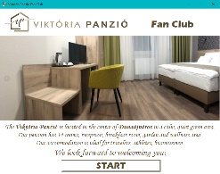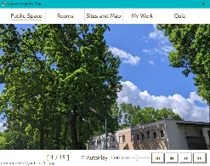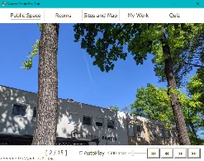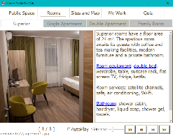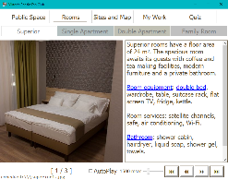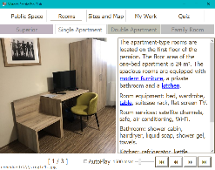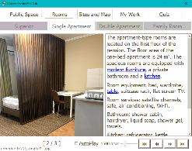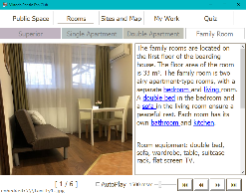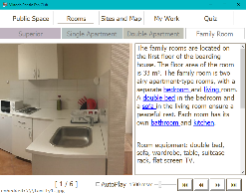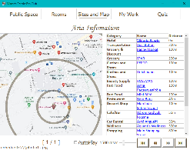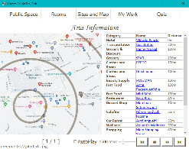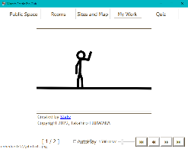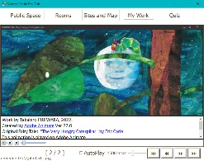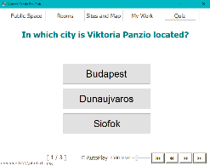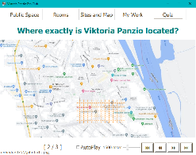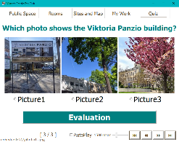

Public Space

Top

Room

Site and Map

My Work

Quiz

🡸Section🡺

🡸Section🡺

🡸Section🡺

🡸Section🡺

🡸Section🡺

🡸Section🡺

### General Navigation

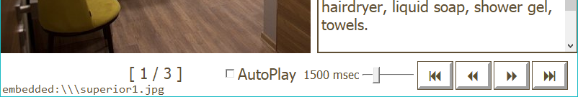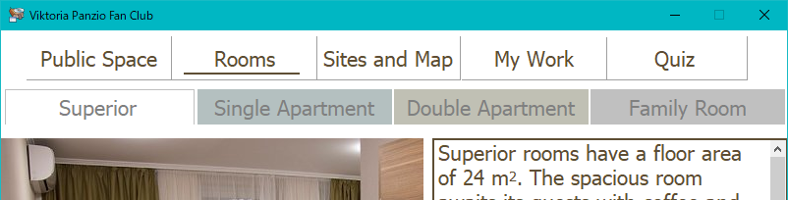

Section Navigation  
Buttons

Section Navigation  
Buttons

Current Section



Next Section

Next Page in the   
Tab / Section

Previous Page in the   
Tab / Section

Previous Section

Page in the Section / Tab

Debug message (only in the debug mode)

### Automatic Play

This publishing content supports automatic play – turn pages automatically.



Checked: AutoPlay On. Unchecked: AutoPlay Off



AutoPlay Control

Page turn duration control slider bar

Page turn duration  
time in msec

## Special Contents “My Work”

### Stykz

This content is created in the subject homework.

### Animation

This content is also created in the subject homework.

## Some ingenuity in the work

### Video File Format in NeoBook

MP4 is not available in NeoBook. I tried some format and the good one is WMV (V9).  
The file is converted by Any Video Converter Professional.

### Embedded File

In the test, changing photo file by a program cause an error. Checked the help in the NeoBook and found the solution. There is a function of Embedded file. So, the all files which is using with the program is added as a embedded file.

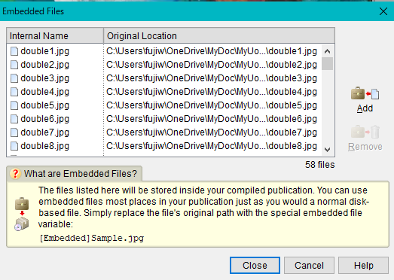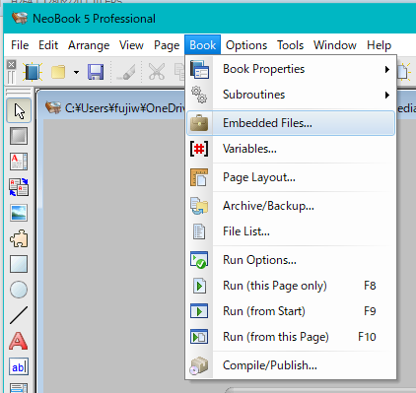

The “embedded file” function is embed the file into the EXE file. The access method is just changing the folder name with [Embedded].

For example,

SetVar "[DebugText]" "[Embedded][PhotoName][PhotoNum].jpg"

Or, specify it as following. For the fixed file is not need to use this solution because the specified file is automatically embedded to the EXE file.

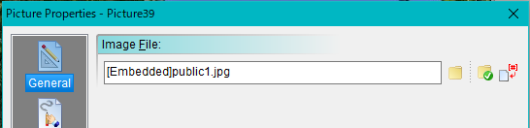

### Pixel size for the picture and movie

This content is targeted to the size 800x600. Therefore all picture and movie file is converted to the actual display size due to avoid scaling process, and also the file size is smaller.

End of document